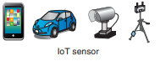

IoT devices (road, vehicle sensors; cameras, mobile, etc.)



Stationary Edge resource manager control servers

Stationary Weather Instruments

5G/cellular network

**Opportunistic BesoEdge Circle Cluster**

Cloud Resources

Figure 1